Distinguished

fellowship

Guidelines

##### JUne 2025

### Engineering New Zealand recognises people who make a significant or eminent contribution to the engineering profession, or New Zealand’s engineering reputation, through its Fellowship programme.

Fellows are individuals who have gone above and beyond their day job to contribute significantly to engineering in New Zealand. The Fellowship programme recognises the profession’s leaders and forms part of a clear pathway for member recognition.

The objectives of the Fellowship programme include to:

* maintain a consistent and high standard for Fellowship
* recognise and reward diversity in the practice of engineering and the wide range of contributions different engineers make to the profession, including across local and central government, academia, and across borders
* recognise contributions made to the engineering profession by people who are ineligible
* to be members of Engineering New Zealand
* be accessible, objective, transparent, fair, and consistent
* be flexible enough to respond to disruptive technologies and global mobility.

# FELLOWSHIP STRUCTURE

The Fellowship programme allows Engineering New Zealand to recognise contributions to the engineering profession in New Zealand or to New Zealand’s engineering reputation by its members and others.

Members of Engineering New Zealand may have their contribution to the profession recognised through being elected to the class of Fellow or Distinguished Fellow. These are Engineering New Zealand’s highest membership classes. They carry substantial prestige and are reserved for the profession’s highest achievers. They form part of a member pathway that offers clear and visible and simple membership progression and career path planning.

Honorary Fellowships recognise contributions to the engineering profession by non-engineers or engineers not practising in New Zealand whose contribution has been through an affiliation with an equivalent overseas body[1].

These guidelines apply to nominations for the class of Distinguished Fellow. For applications for the class

of Fellow and nominations for the class of Honorary Fellow, please see the Fellowship Guidelines.

Figure 1: Fellowship structure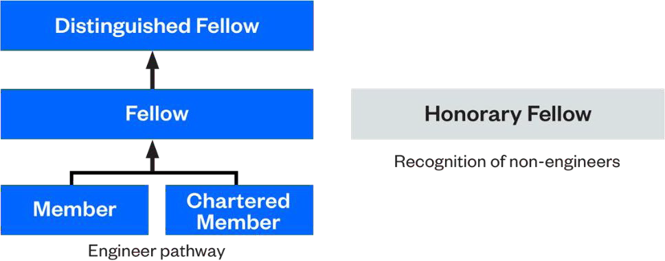

# NOMINATION AND DECISION-MAKING PROCESSES

Distinguished Fellows are Fellows who are recognised for their eminent contribution to the profession. This is the top tier of membership. The standard for Distinguished Fellow is exceedingly high.

## ELIGIBILITY FOR DISTINGUISHED FELLOWSHIP

To be eligible for election to the class of Distinguished Fellow you must:

* be a Fellow of Engineering New Zealand
* have the attributes and eminence expected of a Distinguished Fellow of Engineering New Zealand
* have contributed to the profession significantly since being recognised as a Fellow.

## ATTRIBUTES OF A DISTINGUISHED FELLOW

The difference between a Fellow and a Distinguished Fellow is eminence, sustained leadership and profile, and mana in the industry and profession.

There is no set checklist of criteria for an award of Distinguished Fellowship, but generally a Distinguished Fellow is someone who has several attributes across the following five categories[2]. In your nomination, please clearly outline how the candidate demonstrates attributes from the following categories.

|  |  |
| --- | --- |
| Category | Example of attributes |
| Ethics | * High ethical conduct |
| Distinction | * Widely respected within the profession * Widely respected beyond the profession * High level of seniority in their chosen field |
| Leadership | * Demonstrated thought or people leadership * Involved in public debate to advance engineering knowledge * Influence for the benefit of the profession |
| Inspiration | * Inspirational * Role model * Upholds and lives the values of the profession * Involvement in mentoring |
| Contribution | * Dedication/service to Engineering New Zealand * Significant contribution to engineering beyond their normal employment * Contributes to engineering issues nationally and internationally |

There is no set quota of Distinguished Fellows, but it should be approximately one per cent of the Chartered Membership.

## NOMINATION PROCESS

Candidates for Distinguished Fellow are considered annually by nomination only. Nominations can be made by members of the Distinguished Fellows Panel, the Board, or current Distinguished Fellows or Fellows.

Applications are now open, with this year’s closing date being 5pm Monday 1 September 2025. The Distinguished Fellowship Panel will communicate with all Distinguished Fellows in the second quarter of each year to encourage them to identify potential candidates for nomination.

Nominations must be submitted using the Distinguished Fellowship nomination form[3]. Nominations must include the names of two independent referees who have standing in the profession and the knowledge

to provide informed comment on the candidate’s attributes and suitability for an award of Distinguished Fellow. At least one of the referees must be a Distinguished Fellow of Engineering New Zealand or an equivalent institution.

#### Timeline

|  |  |
| --- | --- |
| **Monday 1 September** | Nominations close |
| **October - November** | **Nominations evaluated** |
| **November** | **Successful candidates advised** |
| **March 2026** | **Successful candidates awarded at the Fellows’ Dinner** |

#### Distinguished Fellowship Panel

Nominations are evaluated by the Distinguished Fellows Panel. The Panel is made up of:

* up to five Distinguished Fellows appointed by the Board
* one President’s nominee (approved by the Board, either a Fellow or Distinguished Fellow)
* the Engineering New Zealand Chief Executive.

The President’s nominee is a voting member of the Panel. The Chief Executive is an ex officio member only, with no voting rights.

Together, the Panel should collectively represent a diverse range of engineering disciplines[4].

### Evaluation of nominations

The Distinguished Fellowship Panel:

* evaluates each nomination against the overall objectives of the Fellowship programme, and the level
* of eminence and attributes of a Distinguished Fellow (particularly since becoming a Fellow)
* usually obtains, in confidence, and in follow up to the written submissions, a verbal reference from
* the nominator and referees. The Panel may ask to have a call with the nominators at the Panel meeting
* may approach, in confidence, any other person it deems appropriate in order to obtain their opinion
* on the candidate being nominated for Distinguished Fellowship
* will be objective, fair, transparent and consistent in its evaluation process.

### Role of Panel Chair

The Chair of the Distinguished Fellowship Panel plays a key role in leading the Panel’s evaluation and deliberations process. With secretariat support from Engineering New Zealand, the Chair is responsible for:

* ensuring that all Panel members are aware of Engineering New Zealand’s strategy, the objectives of the Fellowship programme, and these Guidelines
* ensuring that all deliberations are carried out in a respectful, fair, objective, and consistent way
* preparing minutes for all deliberations, which demonstrate the Panel’s objective and fair consideration of nominations
* preparing the report of its recommendations to the Engineering New Zealand Board (including a verbal presentation of the report at the Engineering New Zealand Board meeting, usually in November)
* recommending future Panel members to the Engineering New Zealand Board
* preparing draft citations for each successful nominee
* ensuring that any actions (such as speaking with referees, gathering further information, writing citations) are fairly split between Panel members.

### Recommendations to the Board

For each nomination, the Panel will recommend, with clear reasons, that the Board either approve or decline to elect the candidate to the class of Distinguished Fellow. The voting members of the Panel should be unanimous in their recommendations to the Board.

The Board will consider the recommendations of the Panel. Where the Board disagrees with the Panel’s recommendation, it will give its written reasons to the Panel and ask the Panel to reconsider. If the Board and Panel cannot agree, the Senior Office Holders will work with the Panel to reach an agreed solution.

### Notification of decision

The nominator will be advised of the outcome of the nomination by 28 November 2025.

Successful candidates are contacted by the Chief Executive/President who will ascertain their willingness to accept the nomination. Successful nominees are awarded their Distinguished Fellowship at an Engineering New Zealand event, usually in March.

If the nomination is not successful, the Panel provides feedback to the nominator on the reasons for the decision.

1. Engineers in New Zealand who have made a significant contribution to the engineering profession and are not Engineering New Zealand members, but who are eligible for membership, may be approached by the Chief Executive and invited to apply for membership first, and then for Fellowship under the member pathway.
2. Attributes were grouped into categories for panel review in the 2021.
3. The nominator will usually make the nomination without the nominee’s knowledge, to ensure the nominees expectations are not raised.
4. All appointments are made by the Board. With the exception of the President’s nominee, each Panel member is appointed for a term of up to five years and at the Board’s discretion, with one member retiring each year. The President’s nominee may be appointed for a two-year term. New appointments are made in March/April of each year. The Panel Chair role will usually rotate so that each Panel member serves one year as Chair in their last year before retiring from the Panel. If a conflict of interest exists, a Panel member will withdraw themselves from considering that particular nomination.